1). Plotting **forest fire** HRR and input number of firebrands in the same plot.

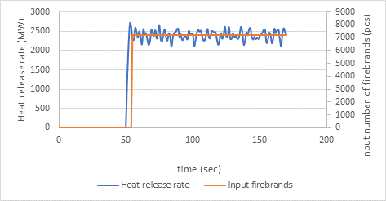

Here I input 7223pcs/s. This is the adjustment for current firebrand flux on the firebrand collection sites. According to the calculation input number vs HRR is 3.008 pcs/MW.

2. Trying to get a better plot for input number and HRR of single tree burning by removing some numbers before 7 seconds and after 30 seconds.

This simulation was conducted with Haider and Levenspiel model to compare with the particle mass distribution in the FDS default drag model.

|  |
| --- |
| Before the adjustment (0 second to 35 seconds)  Total input number = 347 pcs. |
| After the adjustment (8 seconds to 28 second)  Total input number = 287 pcs |

In the experiment total firebrand mass collected (g)                                                   = 18 $∓$ 4

In default drag model total firebrand mass collected (g)                                             = 18.63

In Haider model total firebrand mass collected before the adjustment (g)               = 21.77

In Haider model total firebrand mass collected after the adjustment (g)                 = 18.82

Therefore, the total firebrand mass has been closed to the experiment value after the adjustment in the Haider model.

Input number vs HRR of Haider before the adjustment    = 6.57 pcs/MW

Input number vs HRR of Haider after the adjustment       = 5.61 pcs/MW

3.Plotting the contour maps of firebrand mass distributions of the default drag model and Haider model in single tree burning.

The tree is located at XY=(0,0) coordinates.

|  |
| --- |
| Default drag model  Total mass collected = 18.63 g |
| Haider and Levenspiel drag model  Total mass collected = 18.82g |

Forest fire simulation

Characteristic fire size:

$$D^{*}={(\frac{Q^{0}}{ρ_{∞}C_{p}T_{∞}\sqrt{g}})}^{\frac{2}{5}}$$

$Q^{0}$ =fire size (kw)

$Q^{0}$ = 9230 kW/m2 x 130 m x 2m = 2 399 800 kW

=1.193 kg/m3

=1 kJ/kg.K

=286 K

G=9.81 m/s2

=21.9045 m

|  |  |  |  |
| --- | --- | --- | --- |
|  | $$\frac{D^{*}}{δx}=4$$ | $$\frac{D^{*}}{δx}=12$$ | $$\frac{D^{*}}{δx}=16$$ |
| $$δx$$ | 5.48m | 1.83 m | 1.37m |

Near field and far field

Wind velocities

Velocity devices at 0 m, 1m, 2 m, 3 m, 4 m, 5 m, 6 m, 7 m, 8 m, 9 m, 10 m, 15 m, 20 m, 30 m, 40 m, 50 m, 60 m, 70 m, 80 m, 100 m, 120 m, 140 m, 160 m, 180 m heights.

|  |
| --- |
|  |
|  |

